**Assessment March 20 2023**

Muhammed Ali Masood

Driver table

create table driver

(

dcode int primary key,

dname varchar(255),

dob date,

gender varchar(255)

)

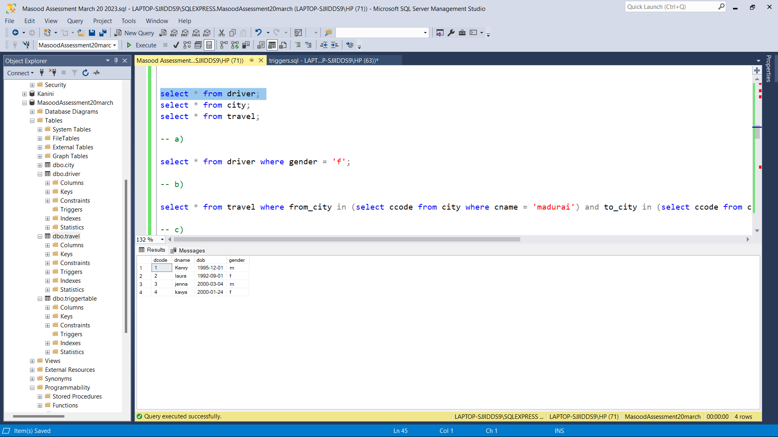

City table

create table city

(

ccode int primary key,

cname varchar(255),

)

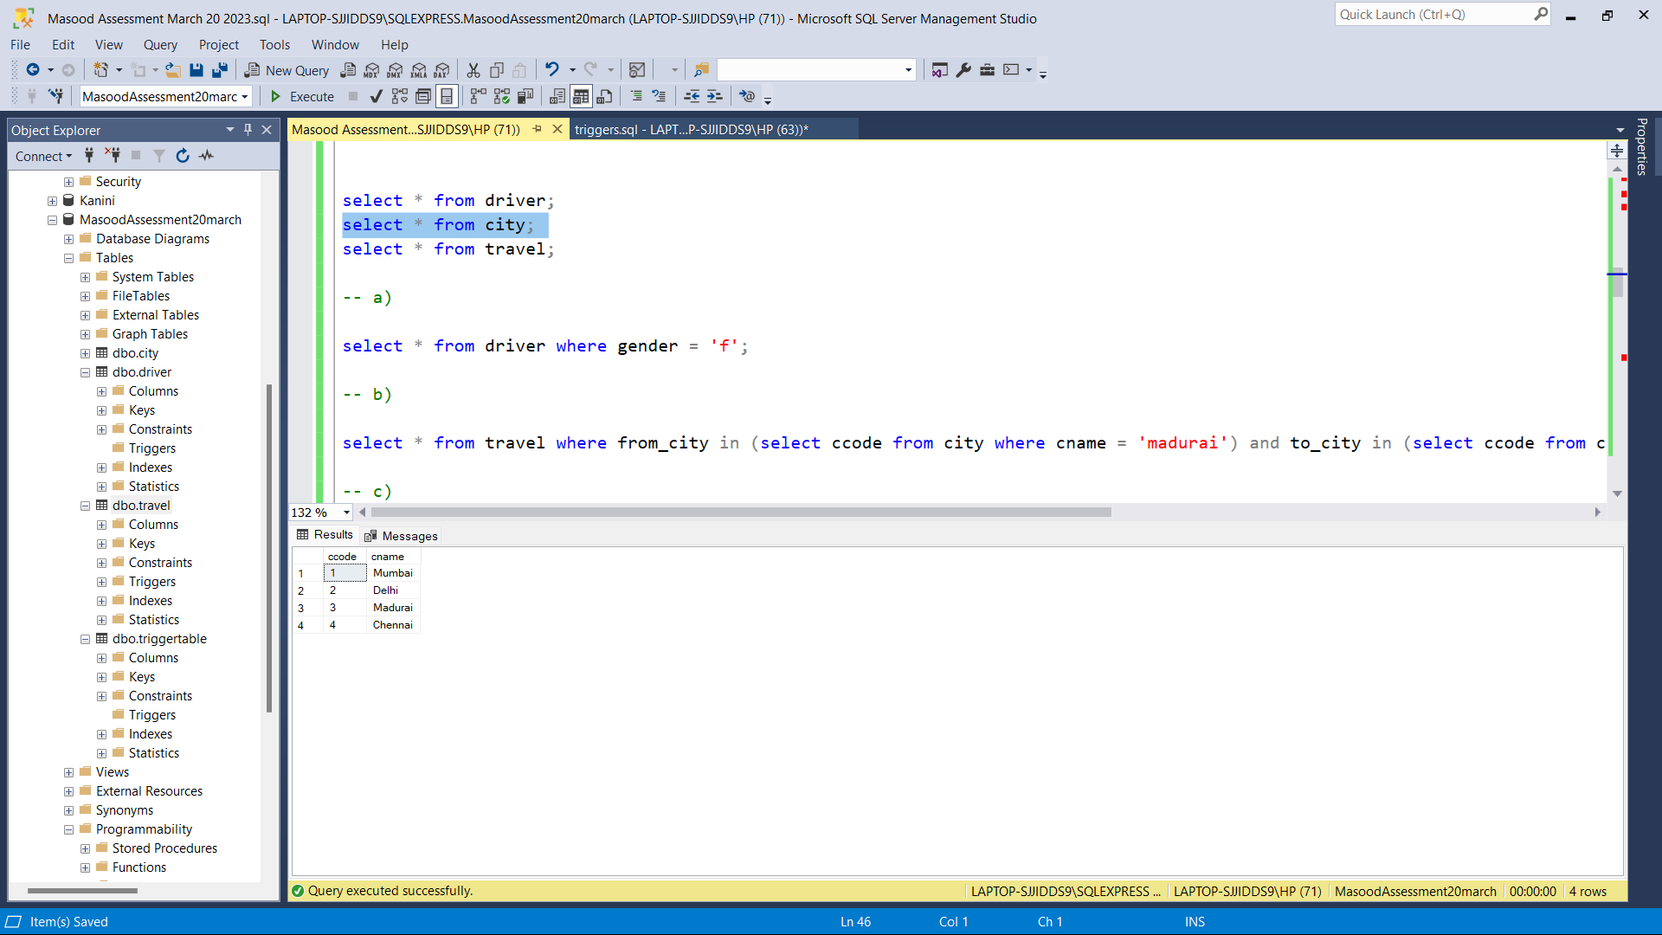

Travel table

create table travel

(

tripid int primary key,

dcode int foreign key

references driver(dcode),

date date,

from_city int,

to_city int

)

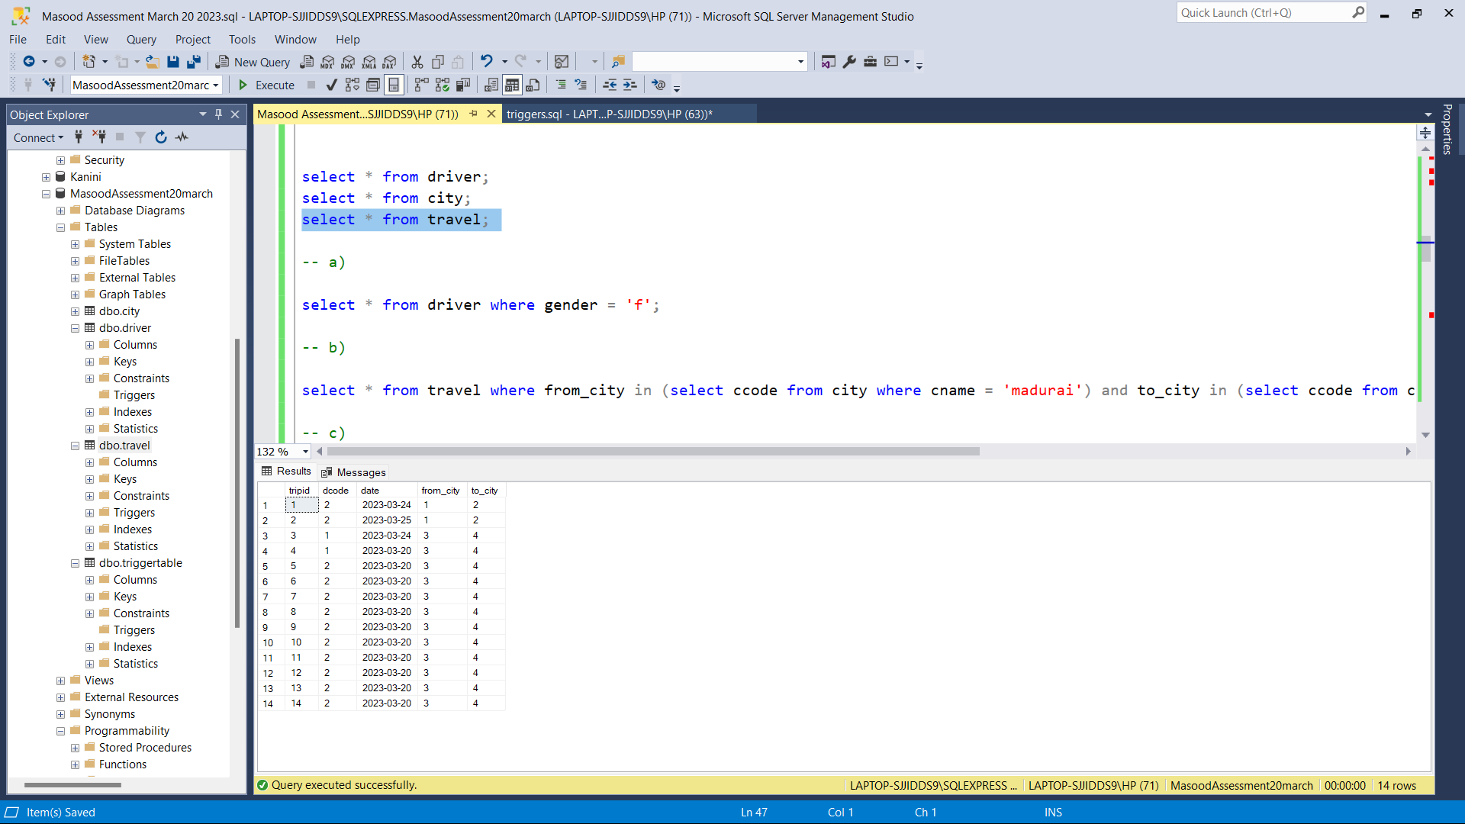

A)

select * from driver where gender = 'f';

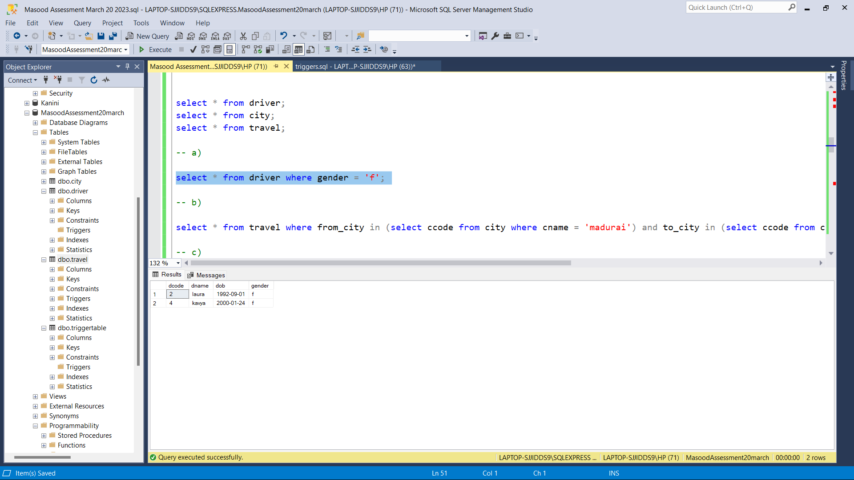

B)

select * from travel where from_city in (select ccode from city where cname = 'madurai') and to_city in (select ccode from city where cname = 'chennai');

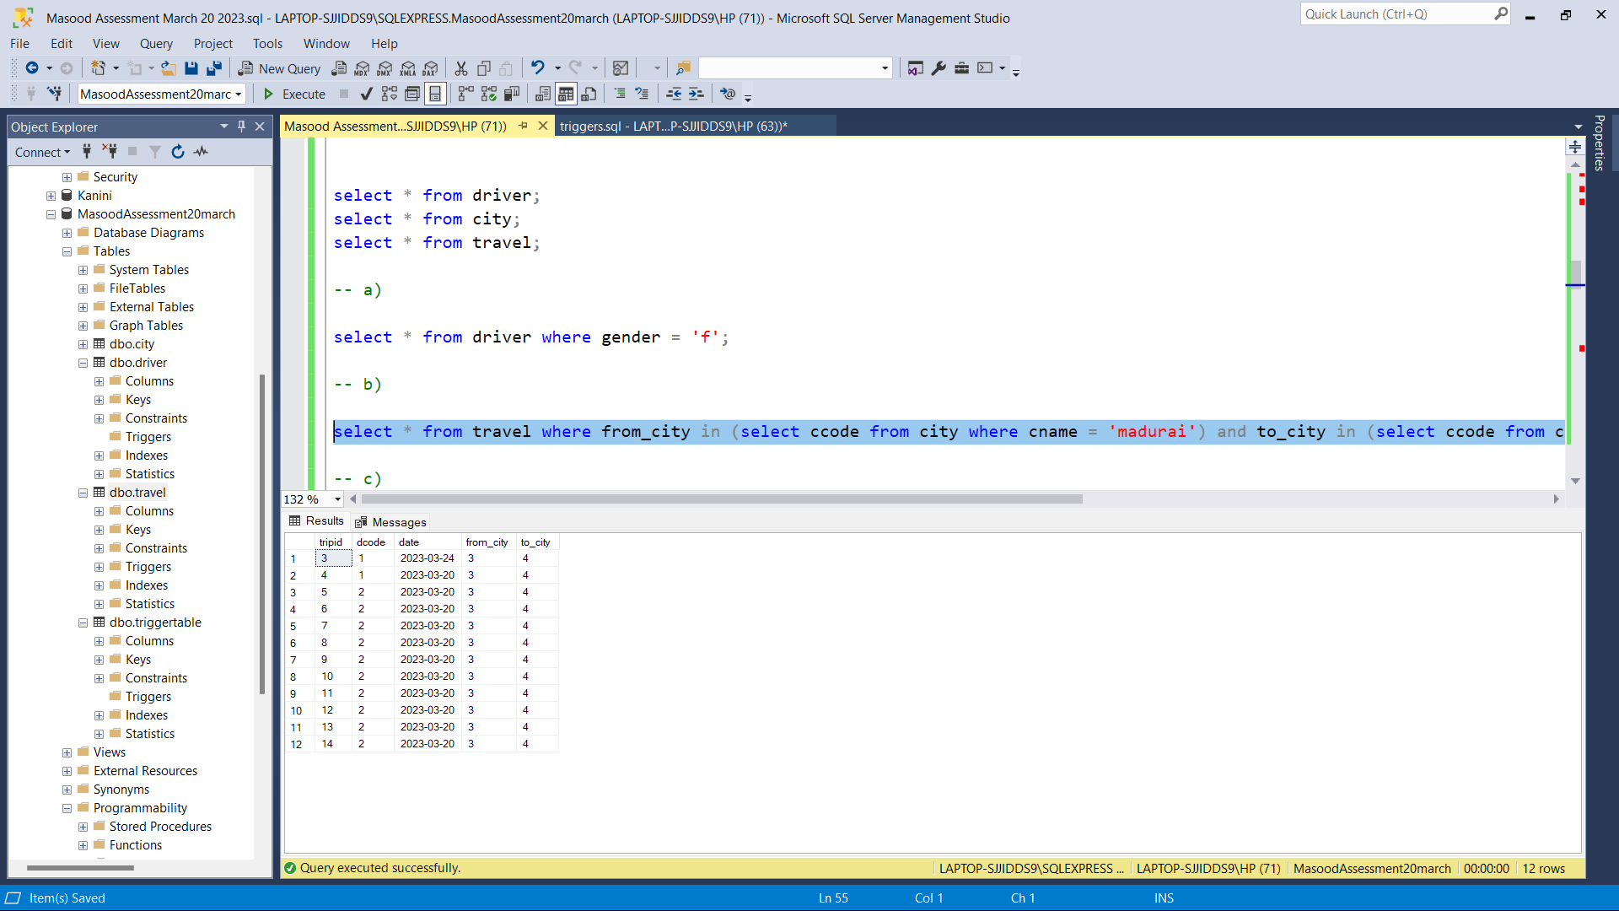

C)

select tripid from travel t inner join driver d on t.dcode = d.dcode where d.dname = 'kenry';

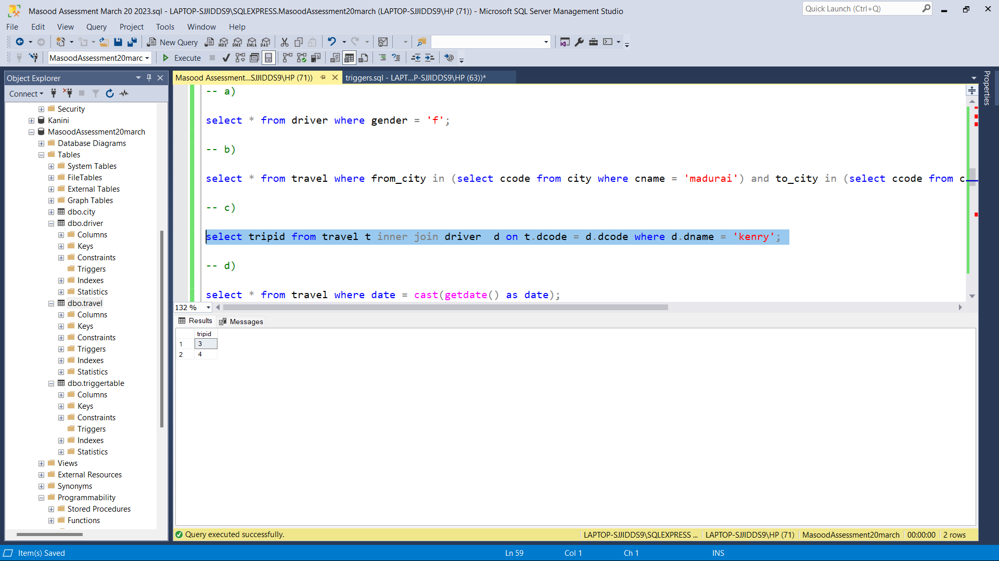D)

select * from travel where date = cast(getdate() as date);

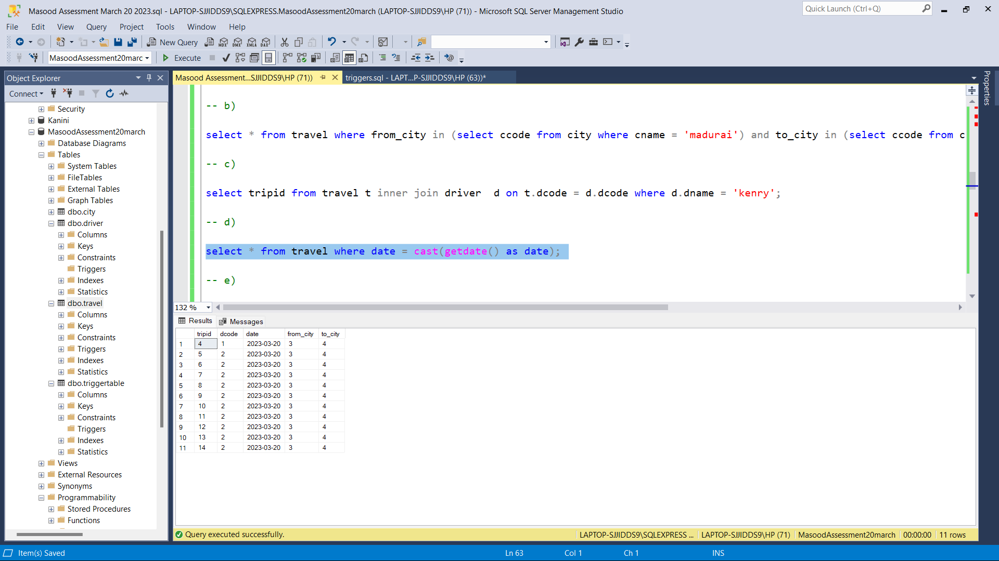

E)

create or alter function tot_trips()

returns table

as

return

(

select count(*) totaltrips from travel where from_city in (select ccode from city where cname = 'mumbai') and to_city in (select ccode from city where cname = 'delhi')

)

go

select * from tot_trips();

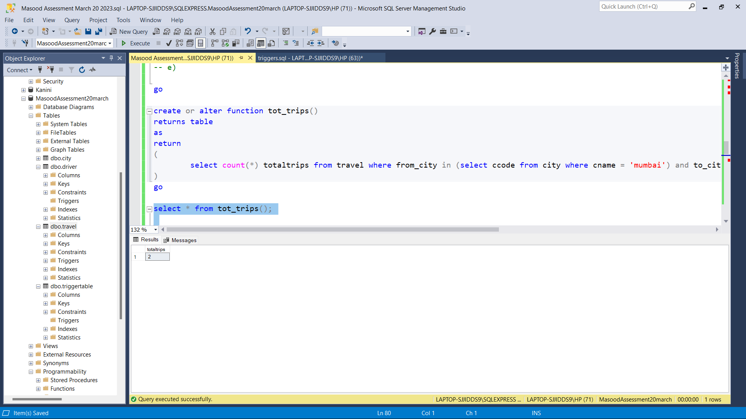

F)

create table triggertable (

LogID int IDENTITY(1,1) NOT NULL,

UpdatedDate Datetime NOT NULL,

Operation nvarchar(10) NOT NULL

)

go

-- insert

create or alter trigger dbo.travelinsert

on dbo.travel

for insert

AS

INSERT INTO dbo.triggertable(UpdatedDate,Operation)select getdate(), 'INSERT' from inserted;

go

insert into travel values(15,2,'2023-03-20',3,4);

go

-- update

create or alter trigger dbo.travelupdate

on dbo.travel

after update

as

INSERT INTO dbo.triggertable(UpdatedDate,Operation)select getdate(),'UPDATE' from deleted;

update travel set dcode = 2 where tripid in (1,2);

update travel set dcode = 1 where tripid in (3,4);

go

-- delete

create or alter trigger dbo.traveldelete

on dbo.travel

instead of delete

AS

INSERT INTO dbo.triggertable(UpdatedDate, Operation)select getdate(), 'DELETE' from deleted;

delete from travel where dcode = 1;

select * from triggertable;

select * from travel;

